FULLY WORKED SOLUTIONS
Context 4: The physics of fun
Chapter 11: Hang on!
Chapter questions
1. (a) W = Fs = 300 × 5 = 1500 J
(b) W = Fs = mgs = 20 × 9.8 × 2 = 392 J
(c) 0
2. (a) W = Fs = mgs = 30 × 9.8 × 3.2 = 940 J
(b) –940 J
3. W = Fs cos θ = 10 × 12 × cos 40° = 92 J
4. (a) 0 = mgΔh + ½m (v² – u²) + F_{f}d
0 = (0.1 × 9.8 × 2.8) + ½ × 0.1 × (0 – 8²) + 2.8F_{f}
0 = 2.744 – 3.2 + 2.8F_{f}
0.456 = 2.8F_{f}
F_{f} = 0.16 N
(b) 0 = (0.1 × 9.8 × –2.8) + ½ × 0.1 × (v² – 0²) + 0.163 × 2.8
0 = –2.744 + 0.05v² + 0.456
2.29 = 0.05v²
v = 6.8 m s^{–1}
5. d = 2.5/sin 37° = 4.15 m
(a) 0 = mgΔh + ½m(v² – u²) + F_{f}d
0 = (40 × 9.8 × (–2.5)) + ½ × 40 × v² + 12 × 4.15
0 = –980 + 20v² + 49.8
930.2 = 20v²
v = 6.8 m s^{–1}
(b) 0 = (40 × 9.8 × (–1.25)) + ½ × 40 × v² + 12 × 2.08
0 = –490 + 20v² + 25
465 = 20 v²
v = 4.8 m s^{–1}
6. (a) E_{k} = 0
(b) 0 = mgΔh + ½m(v² – u²)
0 = (60 × 9.8 × (–2.5)) + ½ × 60 × v²
1470 = 30 v²
v = 7 m s^{–1}
(c) E_{gp} = mgh = 60 × 9.8 × 1.5 = 882 J
(d) 0 = (60 × 9.8 × –1.5) + ½ × 60 v²
882 = 30 v²
v = 5.4 m s^{–1}
7. (a) 0 effectively
(b) 0 = mgΔh + ½m(v² – u²)
0 = 3000 × 9.8 × – 35 + ½ × 3000v²
1.029 × 10⁶ = 1500 v²
v = 26.2 m s^{–1}
(c) 0 = (3000 × 9.8 × 18) + ½ × 3000 × (v² – 26.2²)
0 = 529 200 + 1500v² – 1.03 × 10⁶
5 × 10⁵ = 1500v²
v = 18.3 m s^{–1}
8. (a) W = ΔE_{gp} = mgΔh = 3200 × 9.8 × 45 = 1.4 × 10⁶ J
(b) t = W/P = 1.4 × 10⁶/1.24 × 10⁴ = 114 s
9. (a) W = ΔE_{gp} = mgΔh = 2200 × 9.8 × (10 – 45) = –7.5 × 10⁵ J
(b) W = 2200 × 9.8 × (28 – 10) = 3.9 × 10⁵ J
(c) W = 2200 × 9.8 × (0 – 28) = –6.0 × 10⁵ J

Review questions
10. m = 60 kg+ 10 kg = 70 kg, s = 10 m, θ = 0°
(a) W = Fs cos θ = mgs cos θ
W = 70 × 9.8 × 10 × cos 0° = 6 860 J ≈ 6.9 kJ
(b) P = $\frac{W}{t}=\frac{\text{6860}}{\text{40}}=\text{171}\text{.}5 W≈1\text{.}7×{\text{10}}^{2} W$
11. (a) PE₁ = PE₂ + energy dissipated
PE₁ = mgh₁ = 2mg
PE₂ = mgh₂ = 1.2mg
$\begin{aligned}\text{Percentage} \text{dissipated}=\frac{\text{energy} \text{dissipated}}{{\text{PE}}_{1}}×\text{100}\text{\%} \\ \frac{\text{mg} (2−1\text{.}2)}{\text{mg} 2}×\text{100}\text{\%} \\ \frac{0\text{.}8}{2}×\text{100}\text{\%} = \text{40}\text{\%}\end{aligned}$
(b) The energy is dissipated in the form of heat.
12. (a) m = 0.1 kg, u = 12 m s^{–1}, h_{i} = 0, h_{f} = 5 m, d = 5 m, v = 0
0 = mg(h_{f} – h_{i}) + $\frac{1}{2}$m(v² – u²) + F_{f}d
0 = 0.1 × 9.8 × (5 – 0) + $\frac{1}{2}$ × 0.1 × (0 – 12²) + F_{f} × 5
0 = 4.9 – 7.2 + 5F_{f}
0 = –2.3 + 5F_{f}
2.3 = 5F_{f}
F_{f} = 0.46 N
(b) m = 0.1 kg, u = 0, h_{i} = 5, h_{f} = 0, F_{f} = 0.46, d = 5 m
0 = 0.1 × 9.8 × (0 – 5) + $\frac{1}{2}$ × 0.1 × (v² – 0) + 0.46 × 5
0 = –4.9 + 0.05v² + 2.3
0 = –2.6 + 0.05v²
2.6 = 0.05v²
v = 7.2 m s^{–1}
13. (a) m = 25 kg, Δh = 1 m
E_{gp} = mgΔh = 25 × 9.8 × 1 = 245 J
(b) W = ΔE_{gp} = 245 J
(c) If there is no friction, then W = 245 J
(d) As the driver would have to work against friction as well as gravity in option B, it would be easier to go with option A, in which gravity alone is being worked against. (However, in terms of mechanical advantage, option B would be better.)
14. (a) W = ΔE_{elastic} = F_{elastic}Δx = 1500 × 0.08 = 120 J
(b) Increase in E_{k} = release of E_{elastic}
120 = $\frac{1}{2}$m(v² – u²)
120 = $\frac{1}{2}$× 30 × (v² – 0)
120 = 15v²
v = 2.83 m s^{–1}
(c) u = 2.83 m s^{–1}, m = 30 kg, h_{i} = 0, v = 0
0 = mg(h_{f} – h_{i}) + $\frac{1}{2}$m(v² – u²)
0 = 30 × 9.8 × (h_{f} – 0) + $\frac{1}{2}$ × 30 × (0² – 2.83²)
0 = 294h_{f} – 120
120 = 294h_{f}
h_{f} = 0.41 m
15. (a) F_{f} = 270 N, d = 60 m, m = 1200 kg, v_{A} = 8 m s^{–1}, Δh = h_{B} – h_{A} = –30 m
0 = mgΔh + $\frac{1}{2}$m(v² – u²) + F_{f}d
0 = 1200 × 9.8 × -30 + ½ × 1200 × (v_{B}² – 8²) + 270 × 60
0 = - 3.53 × 10⁵ + 600v_{B}² – 3.84 × 10⁴ + 1.6 × 10⁴
0 = - 3.75 × 10⁵ + 600v_{B}²
3.75 × 10⁵ = 600v_{B}²
v_{B} = 25 m s^{–1}
(b) W_{friction} = F_{f}d = 270 × 60 = 1.6 × 10⁴ J
W_{gp} = mgΔh = 1200 × 9.8 × -30 = 3.53 × 10⁵ J
Percentage loss = $\frac{1\text{.}6×{\text{10}}^{4}}{3\text{.}\text{53}×{\text{10}}^{5}}×\text{100}\text{\%}=4\text{.}5\text{\%}$
16. (a) w_{apparent} = w + ma
= 50 × 9.8 + 50 × 4
= 690 N
m_{apparent} = $\frac{w_{\text{apparent}}}{g}=\frac{\text{690}}{9\text{.}8}$ = 70.4 kg ≈ 70 kg
(b) As there is no change in acceleration, m_{apparent} = m = 50 kg
(c) a = –2 m s^{–2}
w_{apparant} = w + ma = (50 × 9.8) + (50 × –2) = 390 N
m_{apparent} = $\frac{w_{\text{apparent}}}{g}=\frac{\text{390}}{9\text{.}8}$ = 39.8 kg ≈ 40 kg
(d) a = –(–2 m s^{–2}) = 2 m s^{–2}
w_{apparent} = m(g + a) = 50 × (9.8 +2) = 590 N
m_{apparent} = $\frac{w_{\text{apparent}}}{g}=\frac{\text{590}}{9\text{.}8}$ = 60.2 kg ≈ 60 kg
17.
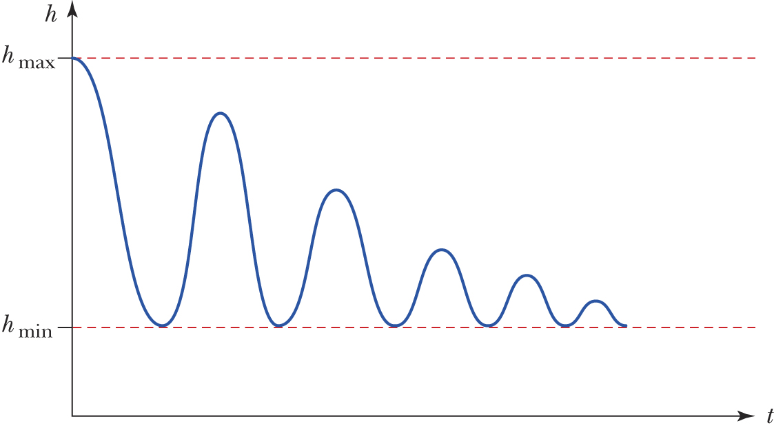
19. m = 1 500 kg, h_{f} = 70 m, h_{i} = 0, t = 3 min = 180 s, u = 0, v = 4 m s^{–1}
w = mg (h_{f} – h_{i}) + $\frac{1}{2}$m(v² – u²)
= 1 500 × 9.8 (70 – 0) + $\frac{1}{2}$ × 1 500 (4² – 0)
= 1.04 × 10⁶ J
P = $\frac{W}{t}=\frac{1\text{.}\text{04}×{\text{10}}^{6}}{\text{180}}=5\text{.}8×{\text{10}}^{3} W=5\text{.}8 \text{kW}$

